Geosim to Trackmap Interface (GTI) for Helicopter Resources.

Aim: Simulate aerial seeding or survey flying.

Pilots can receive instruction on how to use the Trackmap unit in a controlled environment.
The pilots can practice the necessary flying methods while using the Trackmap to produce GPS guided tracks over the ground. Those skills can then be applied into the field for aerial seeding or survey flying.

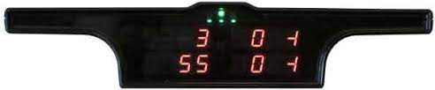

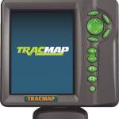For details about Trackmap: https://tracmap.com/aviation/

Method: Interface the Geosim to the Trackmap.

The Geosim flight simulator is based on X-plane 10.
X-plane has a feature where the location of the simulated aircraft can be sent out the PC serial port as a GPS NMEA sentence.

Below is an example of the NMEA sentences.
$GPGGA,092750.000,5321.6802,N,00630.3372,W,1,8,1.03,61.7,M,55.2,M,,*76
$GPGSA,A,3,10,07,05,02,29,04,08,13,,,,,1.72,1.03,1.38*0A
$GPGSV,3,1,11,10,63,137,17,07,61,098,15,05,59,290,20,08,54,157,30*70
$GPGSV,3,2,11,02,39,223,19,13,28,070,17,26,23,252,,04,14,186,14*79
$GPGSV,3,3,11,29,09,301,24,16,09,020,,36,,,*76
$GPRMC,092750.000,A,5321.6802,N,00630.3372,W,0.02,31.66,280511,,,A*43
$GPGGA,092751.000,5321.6802,N,00630.3371,W,1,8,1.03,61.7,M,55.3,M,,*75
$GPGSA,A,3,10,07,05,02,29,04,08,13,,,,,1.72,1.03,1.38*0A
$GPGSV,3,1,11,10,63,137,17,07,61,098,15,05,59,290,20,08,54,157,30*70
$GPGSV,3,2,11,02,39,223,16,13,28,070,17,26,23,252,,04,14,186,15*77
$GPGSV,3,3,11,29,09,301,24,16,09,020,,36,,,*76
$GPRMC,092751.000,A,5321.6802,N,00630.3371,W,0.06,31.66,280511,,,A*45

More Info at https://en.wikipedia.org/wiki/NMEA_0183

The GPS NMEA sentence is what the Trackmap would normally receive from its own GPS receiver module. If the TrackMap is then supplied with the X-planes sentence, The trackmap will interpret the data as though it was onboard an aircraft
The Trackmap will be mounted on a custom frame that sits beside the Geosim pilot’s seat. It would be positioned in a similar location to the aircraft. The unit will be powered by a standard 12v battery or a suitable power supply.

The light bar will be placed in the pilots eyeline using its own mount.
The Trackmap switches will be attached to the Geosim cyclic in the same way as the aircraft.

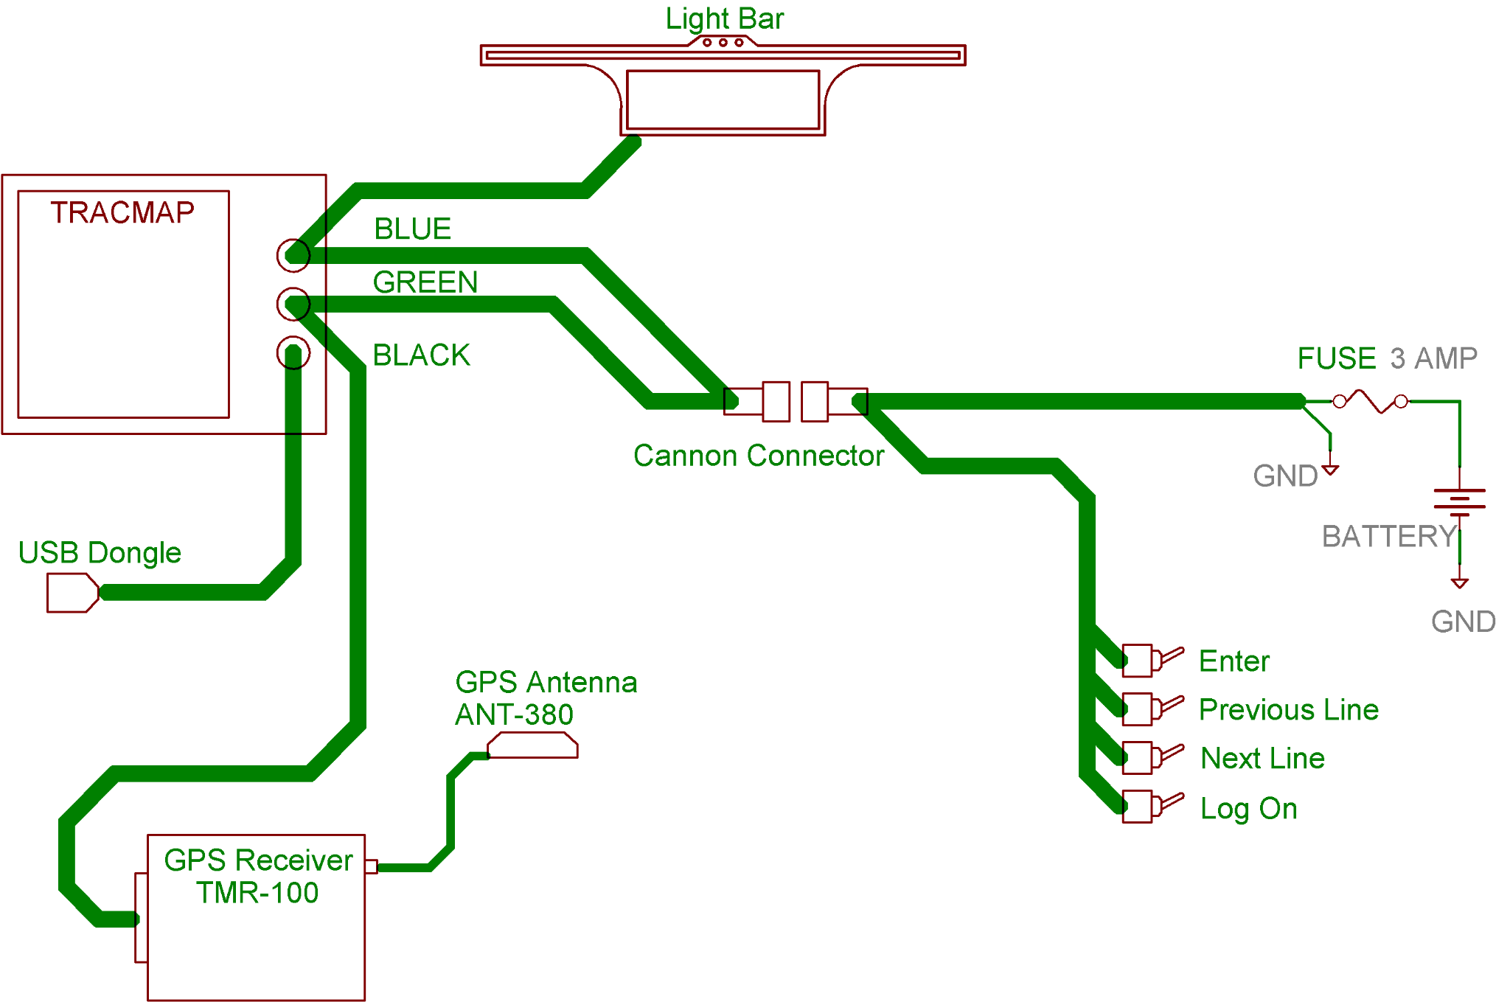
Physical and Digital Interface:

But! ... Unfortunately, it is not a simple task of connecting the Geosim PC to the Trackmap and expecting everything to work..
The Tackmap is expecting an industry-standard RS232 serial input. The data transfer must be at 9600 bits per second or higher.
The Geosim PC does not have standard RS232 serial port as modern PC systems have done away with this method of communication. Additionally, X-plane sends the data out at the NMEA standard rate of 4800 bits per second.

The interface will be built around an Arduino microprocessor.
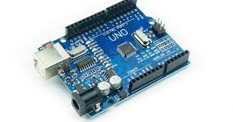

These units are easily obtained from Jaycar or other online sources. The microprocessor (MPU) can be programmed using pre-existing and extensively tested software libraries. One of those libraries is serial communications.
The incoming x-plane NMEA sentence at 4800 bps will be stored inside the MPU. The MPU will check that the sentence is valid then send the NMEA sentence onto the Trackmap at 9600 bps.

Another library will emulate an RS232 serial port over a USB connection. Windows 10 will use its standard drivers to support this and X-plane will think it is communicating to a physical RS232 serial port.

Finally, the MPU will be connected to an RS232 adapter board that creates the required voltage levels to comply with the RS232 standard. For info this is -12V to +12V. The MPU only works on 0V to +5V.
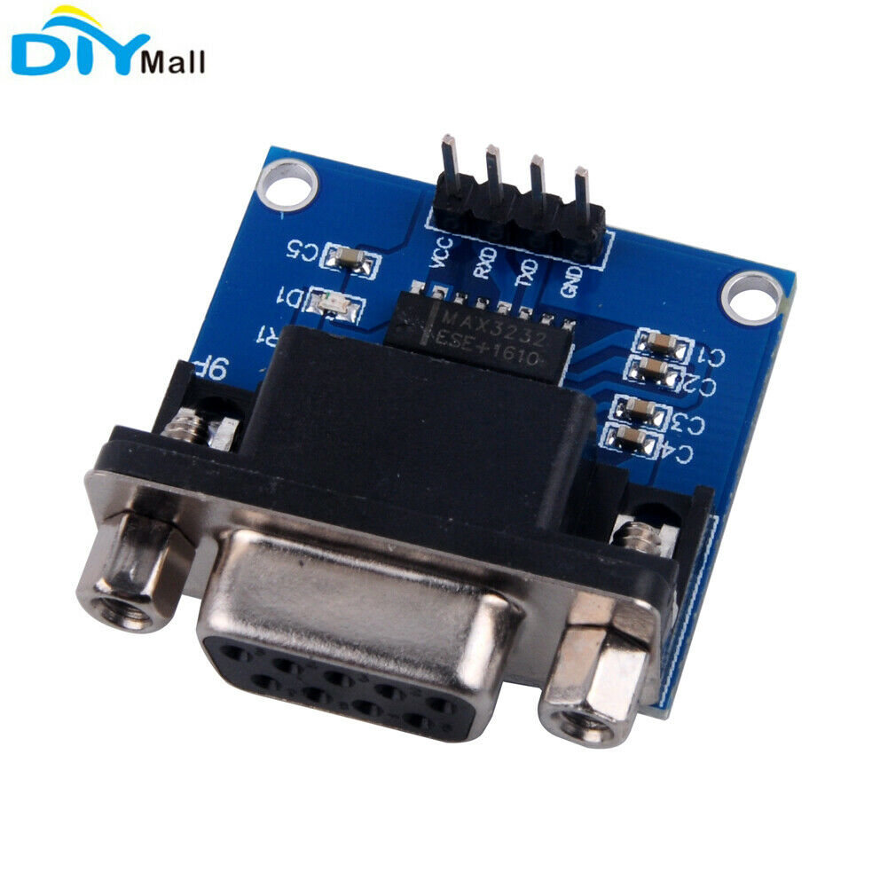

The boards will be mounted into a suitable box and the required physical connections placed on the sides.
Labeled LED lights will be used for status and fault finding.

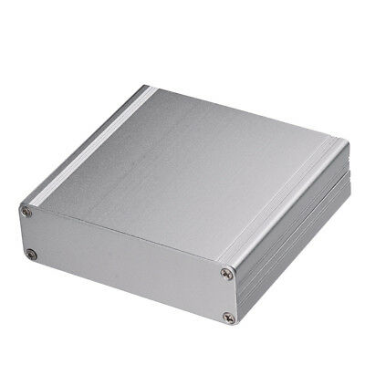

All documents, diagrams, and code will be held on GitHub for future reference.

Cost and ETD:

GTI Hardware - ~$150
- 1x Ardrino Microprocessor
- 1x RS232 Adapter Board
- 1x 200mm Poly box or aluminum box
- 4x Industrial LED lights

Trackmap mounting - ~(inhouse construction)
- 1x Trackmap stand
- 1x Lightbar stand

Isolated and protected 12V power supply - $100

Software and Hardware development - $3640

- Develop the Arduino code - 30 hours
- Assemble units into a box - 10 hours
- Test and debug the system - 10 hours
- Document and backup code. - 2 hours

Estimated Total cost - $3890
Estimated Time to delivery - Three weeks. (2h min per day)

